This document shows the pins currently in use in the final design implementation of SAFE-T’s handheld unit.

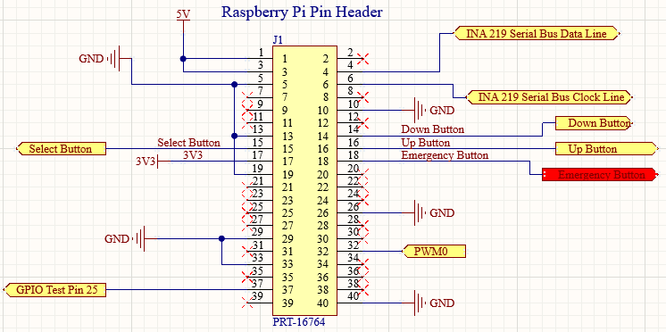

While this diagram details all of the respective pins accounted for, these pins from the Raspberry Pi Zero WH were not soldered directly to the PCB:

* List them please

